Project Design Phase-II
Technology Stack (Architecture & Stack)

Date | 31 January 3035
Team ID | SWTID-2026-2491
Project Name | AI BlogNest API
Maximum Marks | 4 Marks

Technical Architecture:
The Deliverable shall include the architectural diagram as below and the information as per the table1 & table 2
Example: Order processing during pandemics for offline mode
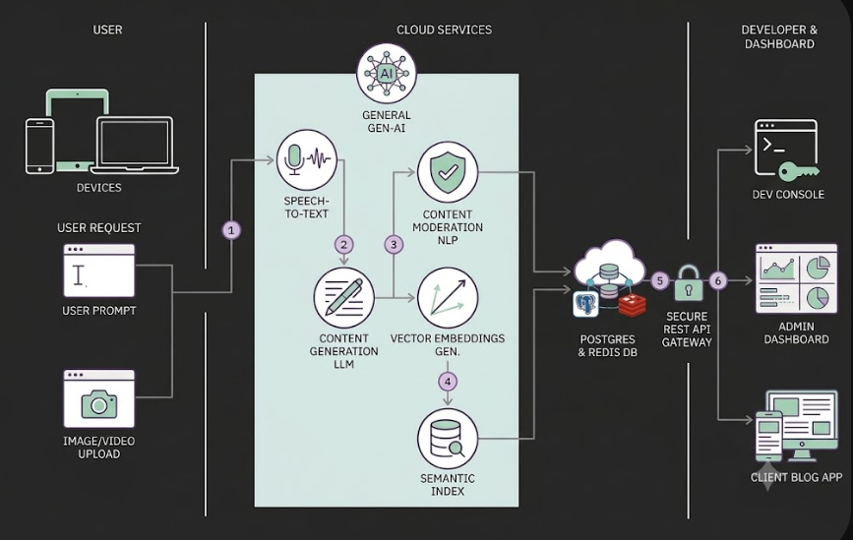
AI BlogNest Architecture Guidelines: • Map App Logic (FastAPI, LangChain, Celery)
• Demarcate Infrastructure (Local Docker vs AWS/GCP Cloud)
• Highlight External APIs (OAuth, SendGrid)
• Detail Data Storage (PostgreSQL, Redis, Vector DB)
• Interface ML/LLMs (OpenAI, Moderation)

Table-1: Components & Technologies
S.No | Component | Description | Technology
1 | User Interface | Client-facing Web Application and API Documentation Portal for interactive blog management and testing. | React.js / Next.js, Tailwind CSS, Swagger UI (OpenAPI 3.0)
2 | Application Logic-1 | Core REST API Backend managing authentication, blog workflows, post CRUD, categories, and database operations. | Python (FastAPI / Django) or Node.js (Express.js)
3 | Application Logic-2 | AI Orchestration & Generation Engine for automated article text generation, summarizing, and outline generation. | OpenAI API (GPT-4) / LangChain / Hugging Face Inference API
4 | Application Logic-3 | Asynchronous Task Execution & AI Image Generation pipeline for background job processing and feature image creation. | Celery / Redis Worker, Stability AI API (Stable Diffusion) / DALL-E API
5 | Database | Primary Relational Database storing user profiles, structured blog posts, tags, comments, and application state. | PostgreSQL / MySQL
6 | Cloud Database | Managed Cloud Database / Vector Store for storing blog content embeddings for semantic search and recommendation systems. | MongoDB Atlas / Pinecone / PostgreSQL with pgvector
7 | File Storage | Cloud Object Storage for user avatars, blog thumbnails, inline images, and exported content files. | Amazon S3 / Google Cloud Storage / Cloudinary
8 | External API-1 | OAuth Identity Providers for seamless third-party user registration and login workflows. | Google Identity Services (Gmail OAuth 2.0), LinkedIn OAuth API
9 | External API-2 | Email & Messaging Gateway for user email verification, OTP dispatch, and transactional notifications. | SendGrid API / Twilio API
10 | Machine Learning Model | Natural Language Processing & Automated Content Moderation Models for spam detection, sentiment analysis, and safety filtering. | Transformer Models (RoBERTa / OpenAI Moderation Endpoint)
11 | Infrastructure (Server / Cloud) | Cloud deployment infrastructure hosting API web workers, background jobs, database services, and container orchestration.  Local Server Configuration: Docker Desktop, Docker Compose, 8GB+ RAM  Cloud Server Configuration: AWS EC2 / GCP Compute Engine with Kubernetes Auto-scaling | AWS / GCP, Docker, Kubernetes, NGINX API Gateway

Table-2: Application Characteristics
S.No | Characteristics | Description | Technology
1 | Open-Source Frameworks | Utilization of robust, open-source server frameworks, ORMs, and AI pipeline orchestration libraries to accelerate development. | FastAPI, SQLAlchemy / Prisma, LangChain, Celery, Redis
2 | Security Implementations | Zero-trust authentication via JWT/OAuth2, HTTPS/TLS encryption for data in transit, bcrypt/Argon2 password hashing, rate-limiting, and CORS policy enforcement. | OAuth 2.0, JWT, SHA-256 / bcrypt, CORS Middleware, OWASP Top 10 Protections
3 | Scalable Architecture | Decoupled Microservices / Modular Monolith pattern separating the high-throughput REST API from long-running asynchronous AI generation tasks using event queues. | Docker Containerization, RabbitMQ / Redis Message Broker, Celery
4 | Availability | Highly available system architecture utilizing multi-zone cloud deployment, load balancing, health checks, and database replication. | NGINX Reverse Proxy / AWS Application Load Balancer (ALB), Kubernetes Cluster
5 | Performance | Sub-200ms REST API response times for CRUD operations, in-memory caching for frequently requested posts, and asynchronous webhooks/polling for AI content generation. | Redis Cache, Cloudflare CDN, Asyncio / Event Loops

